The Intergalactic Adventure of Blob

Hi!

Eric Walker

# Description

The Intergalactic Adventure of Blob is a relatively simple “Helicopter”-type game. The user will try to navigate their blob through a series of obstacles in the intergalactic space of the Bloban universe. Score will be assigned based on progress through the game, and recorded for bragging rights, available on your friendly neighborhood “High Scores” screen.

# Why MVC?

The basic structure of any Helicopter game consists of a model that holds the location of walls and the avatar for the user, a view that the user can interpret, and some sort of controller that takes in user input from the keyboard.

More specifically, the model consists of a list of obstacle objects and an avatar object. This model keeps track of creating or destroying the obstacle objects as the avatar progresses through the game, as well as whether or not the avatar has hit one or more of the walls.

The views for this game are the start screen, the game window, and the high scores page. The start screen is just a welcome page that gives the user options for level, avatar, and obstacle type. The game window is where the action occurs and legends are made. The high scores screen consists of two parts, a mode for entering high scores once they are made and a mode for viewing the legends.

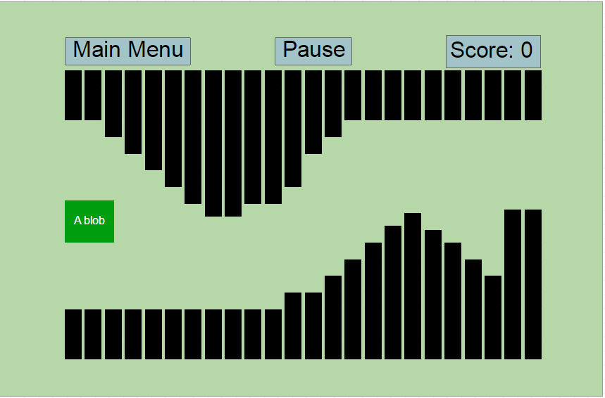Mockups of User Interface

The “game” view of The Intergalactic Adventure of Blob. The user can see their score, as well as go back to the main menu or pause for a snack break.

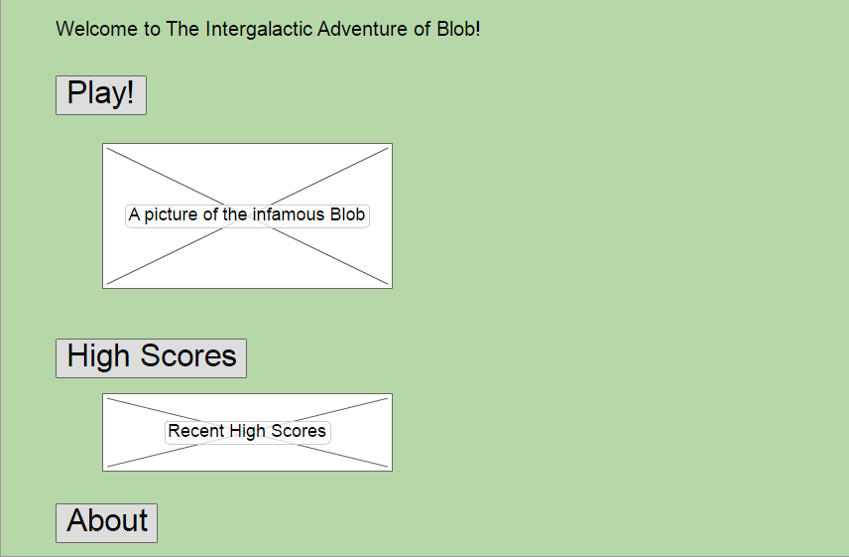The welcome screen view of The Intergalactic Adventure of Blob. The user can either play, view high scores, or see relevant information, such as the readme, source code, lore, or even comics.

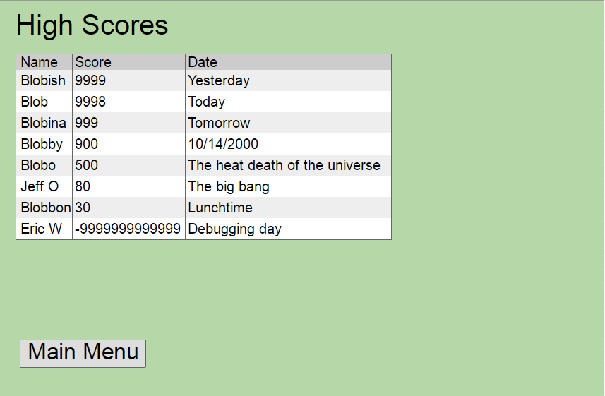The high score view of The Intergalactic Adventure of Blob. The user can view the highest scores since the inception of the program (when someone clicked play in IntelliJ) and see what they need to get to be recorded in the annals of Bloban history. They can also go back to the main menu to play and fight for their spot in history.